Hellenic Accreditation System

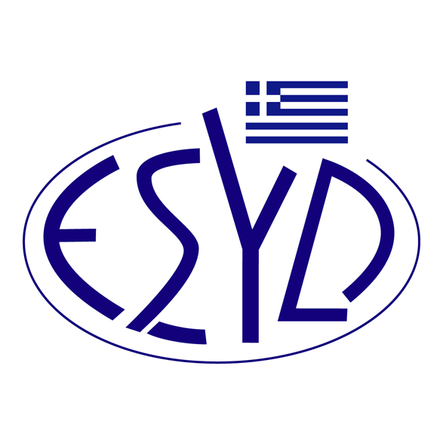

Annex A19/2 to the Certificate No. 193-9

SCOPE OF ACCREDITATION
of

EQA – ΗELLAS CERTIFICATION & INSPECTION BODY
SOCIETE ANONYME
(EQA – ΗELLAS S.A.)

as a Certification Body of Medical Devices Quality Management Systems
in accordance with ELOT ΕΝ ΙSΟ 13485:2016

Main Technical Areas ⁽¹⁾ | Technical Areas ⁽¹⁾
Parts or services | Distribution services.
 | Maintenance services.
 | Transportation services
⁽¹⁾ According to IAF MD 8:2020.

Address of the Body : 30 Potamou Kalama St., 152 33 Chalandri, Greece.
Approved Signatory : Charalampos Galatsanos

This Scope of Accreditation replaces the previous one dated 16.12.2024.
The Accreditation Certificate Νο. 193-9, according to ELOT EN ISO/IEC 17021-1:2015, has been extended up to 16.09.2025, according to ESYD decision.

Athens, 10.03.2025

Konstantinou Evangelos Apostolos
CEO of ESYD

