Hellenic Accreditation System

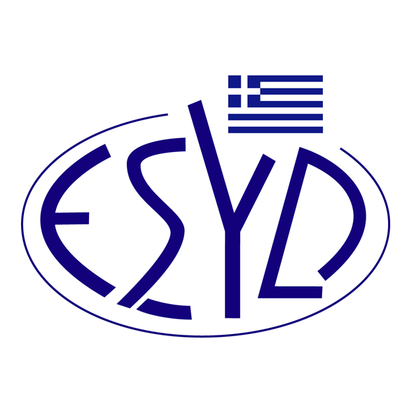
Annex A7/3 to the Certificate No. 1306

SCOPE of ACCREDITATION
of

COSMOCERT CERTIFICATION SERVICES
SOCIETE ANONYME

as a Certification Body
of Food Safety Management Systems
according to ELOT EN ISO 22000:2018 standard

Category codes | Activity
B | Farming or handling of plants
C | Food, ingredient and pet food processing
F | Trading, retail and e-commerce

Address of the Body: 25, D. Kampouroglou str., 115 25 Athens, Greece
Approved signatory: Constantinos Diamantopoulos

This Scope of Accreditation replaces the previous one, dated 08.08.2024.
The Accreditation Certificate No. 1306, according to ELOT EN ISO/IEC 17021-1:2015, is valid until 01.09.2026.
Accreditation granted according to ISO 22003-1:2022.

Athens, 23.01.2025

Konstantinou Evangelos Apostolos
CEO of ESYD

