Hellenic Accreditation System

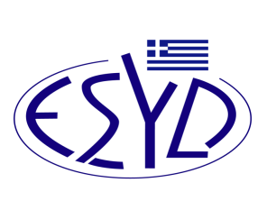
Annex F1/1 to the Certificate No. 1418

SCOPE of ACCREDITATION
of the
Testing Laboratory

PANAGOPOULOS DIMITRIS & Co LP/ GREEN BIOTECH HELLAS
Materials / Products to be tested | Types of test / Properties to be measured | Applied Standards / Techniques to be used

Chemical Tests
Water as solvent in hair samples for the detection of chemicals  substances and biomolecules | Determination of pH | ISO 10523:2008

Site of assessment: Permanent premises: Ioanninon 63, Glyfada , 16674

Approved signatories: Dimitris Panagopoulos.

The Accreditation Certificate No. 1418, according to ELOT EN ISO/IEC 17025:2017, is valid until 30.07.2029.

Athens, 31st July 2024

Christos Nestoras
CEO of ESYD

