Hellenic Accreditation System
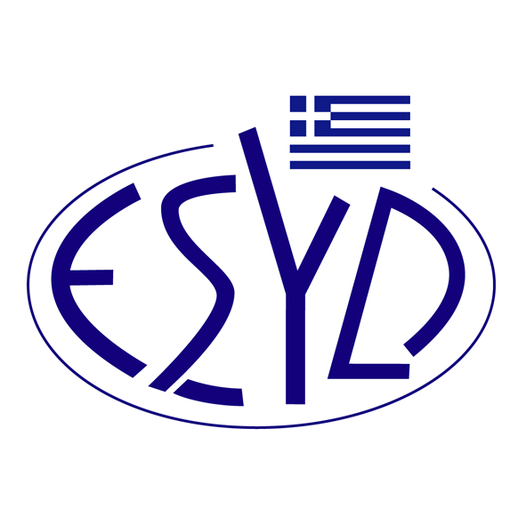

Annex Α13/1 to the Certificate No.725-8

SCOPE of ACCREDITATION
of

Q-check Private Company
(Q-check P.C.)
‘Q-check’

as an Environmental Management Systems Certification Body
in accordance with ELOT EN ISO 14001:2015 Standard

IAF Code⁽¹⁾ | Full ⁽¹⁾or Limited Scope⁽¹⁾ | Accredited Activity ⁽²⁾
3 | Full | Manufacture of food products.
3 | Full | Manufacture of beverages.
3 | Full | Manufacture of tobacco products.
10 | Full | Manufacture of coke and refined petroleum products.
16 | Full | Manufacture of cement, lime and plaster.
16 | Full | Manufacture of articles of concrete, cement and plaster.
17 | Limited | Manufacture of structural metal products.
17 | Limited | Manufacture of tanks, reservoirs and containers of metal.
17 | Limited | Manufacture of steam generators, except central heating hot water boilers.
17 | Limited | Forging, pressing, stamping and roll-forming of metal; powder metallurgy.
IAF Code⁽¹⁾ | Full ⁽¹ ⁾ or Limited Scope⁽¹⁾ | Accredited Activity ⁽²⁾
17  (cont.) | Limited | Treatment and coating of metals; machining.
17  (cont.) | Limited | Manufacture of cutlery, tools and general hardware.
17  (cont.) | Limited | Manufacture of other fabricated metal products.
17  (cont.) | Limited | Repair of fabricated metal products.
18 | Limited | Manufacture of machinery and equipment n.e.c.
18 | Limited | Repair of machinery.
18 | Limited | Installation of industrial machinery and equipment.
24 | Full | Materials recovery.
28 | Full | Construction of buildings.
28 | Full | Civil engineering.
28 | Full | Specialized construction activities.
29 | Full | Wholesale and retail trade and repair of motor vehicles and motorcycles.
29 | Full | Wholesale trade, except of motor vehicles and motorcycles.
29 | Full | Retail trade, except of motor vehicles and motorcycles.
29 | Full | Repair of personal and household goods.
30 | Full | Accommodation.
30 | Full | Food and beverage service activities.
31 | Limited | Warehousing and storage.
34 | Full | Architectural and engineering activities; technical testing and analysis.
34 | Full | Scientific research and development.
34 | Full | Specialized design activities.
IAF Code⁽¹⁾ | Full ⁽¹ ⁾ or Limited Scope⁽¹⁾ | Accredited Activity ⁽²⁾
34  (cont.) | Full | Other professional, scientific and technical activities n.e.c
35 | Full | Legal and accounting activities.
35 | Full | Activities of head offices; management consultancy activities.
35 | Full | Advertising and market research.
35 | Full | Photographic activities.
35 | Full | Translation and interpretation activities.
35 | Full | Employment activities.
35 | Full | Security and investigation activities.
35 | Full | Services to buildings and landscape activities.
35 | Full | Office administrative, office support and other business support activities.
39 | Limited | Waste collection.
39 | Limited | Motion picture, video and television programme activities.
39 | Limited | Programming and broadcasting activities.
39 | Limited | Other information service activities.
39 | Limited | Travel agency, tour operator reservation service and related activities.
39 | Limited | Creative, arts and entertainment activities.
39 | Limited | Libraries, archives, museums and other cultural activities.
39 | Limited | Gambling and betting activities.
39 | Limited | Sports activities and amusement and recreation activities.
39 | Limited | Activities of membership organizations.
39 | Limited | Other personal service activities.

- ΕA/IAF Code according to IAF ID 1:2023
- Eurostat NACE Rev.2

Address of the Body : 9-17 Erithrou Stavrou St., 41221, Larisa, Greece
Approved Signatory : S. Migos

The Accreditation Certificate No. 725-8, according to ELOT EN ISO/IEC 17021-1:2015, is valid until 23.12.2027.

Athens, 30.05.2025

Konstantinou Evangelos Apostolos
CEO of ESYD

