Hellenic Accreditation System
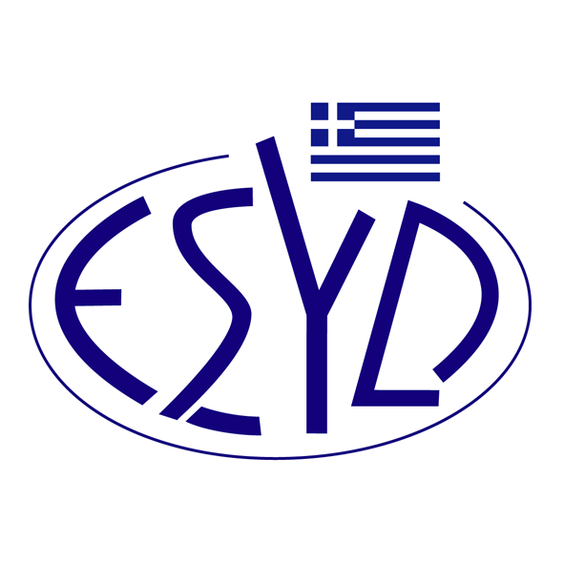
Annex F1/1 to the Certificate No. 1402

SCOPE of ACCREDITATION
of
Drinking Water and Wastewater Testing Laboratory
of
Municipal Εnterprise for Water Supply and Sewerage of Paionia
Materials/Tested products |  | Type of test/Measured properties | Applied standards/  Techniques used
Chemical Tests
Drinking water |  | 1. Determination of pH | HACH method 10257
 |  | 2. Determination of conductivity | HACH method based on ISO 7888:1985
 |  | 3. Determination of turbidity | HACH method 8195
 |  | 4. Determination of anions: Nitrites, Nitrates, Fluorides, Chlorates, Sulphates | In-house method of Ion Chromatography based on EPA Method 300.1
 |  | 5. Determination of Cadmium and Lead | ΕΛΟΤ EN ISO 15586:2003 Atomic Absorption – Graphite Furnace
Microbiological Tests
Drinking Water |  | 1. Enumeration of Escherichia coli and Total Coliforms | ISO 9308-1:2014 / Amd.1:2016
 |  | 2. Detection and enumeration of intestinal enterococci | ISO 7899-2:2000
 |  | 3. Enumeration of culturable microorganisms at 22^{ο}C and 36^{ο}C | ISO 6222:1999

Site of assessment: Permanent laboratory premises, 1ο km Old National Road of Polykastro-Thessaloniki, 61200, Polykastro Kilkis.

Approved Signatory: Papadopoulou Anna, Efthymiou Maria.

The Accreditation Certificate No. 1402, according to ELOT EN ISO/IEC 17025:2017, is valid until 07.05.2029.

Athens, 08.05.2024

Christos Nestoras
CEO of ESYD

