Hellenic Accreditation System
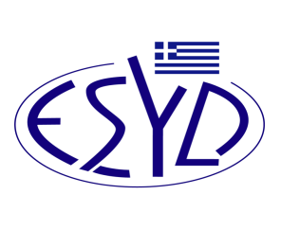
Annex F2/1 to the Certificate No. 1334

SCOPE of ACCREDITATION
of the
Calibration Laboratory
of
QAFA GRAMOZ - SOLUTIONS PLIROFORIKI

 | Measurand / Calibration item | Range of measurement | Calibration & Measurement Capability (k=2)* | Remarks
 | Volume measurements
 | Volume / Steel tanks | 0,2 m³to 50 m³ | 0,1 % (filling tank)  0,11 % (emptying tank)  of nominal tank volume | Volumetric method using volume standard according to:  EURAMET cg-21, v.2.1: 2021  Calibration medium: potable water.  Calibration is performed on site.
 | Volume / Road tankers | 0,2 m³ to 20 m³ | 0,1 %  of nominal tank volume | Volumetric method using volume standard according to:  - EURAMET cg-21, v.2.1: 2021  - OIML R80-2:2017, Annex B  Calibration medium: potable water.  Calibration is performed at laboratory premises or on site.
*Where uncertainty is accompanied by the corresponding unit, it is absolute, while where it is not accompanied by a unit, is relative.
Site of assessment: Permanent laboratory premises, Likomidous 5, 26333 Patra.
Approved Signatories: G. Qafa, P. Farmakis, T. Nikolaou

The Accreditation Certificate No. 1334, to ELOT EN ISO/IEC 17025:2017, is valid until March 14th, 2028.

Athens, March 15th, 2023
Christos Nestoras
CEO of ESYD

