Hellenic Accreditation System

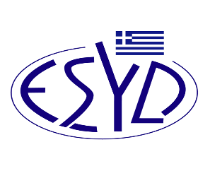

Annex G1/1 to the Certificate No. 1397

SCOPE of ACCREDITATION
of the

Clinical Laboratory

of
PLATON IATRIKI S.A.

Tested materials/ products | Types of test/ Properties to be measured | Applied Standards/ Techniques to be used
Molecular Genetics
Νasopharyngeal (NP) specimen  Nasopharyngeal wash/aspirate or nasal wash/aspirate (NW) specimen | Molecular testing for the detection of viral RNA of SARS-CoV-2 | The extracted RNA from the samples is analyzed by Real - time PCR, using specific primers and protocols based of the Kit: Vazyme. Type: 2019-Novel Coronavirus (2019-nCoV) Triplex RT-qPCR. Total RNA extracts from sample in order to test the potential detection of SARS-CoV-2 RNA. The potential detection of SARS-CoV-2 RNA tests by Real-time PCR, using specific primers to amplify the conserved regions such as N-gene and ORF1-ab gene of SARS-CoV-2. The quality of the  reaction evaluates by using both positive, negative and internal control, which can confirm that the  test is working properly.  Equipment: Bio-Rad - CFX96 Touch Real-Time PCR Detection System.  Extraction: Panagene - Panamax 48, Kit Panamax Viral DNA/RNA.

*Reference to the commercial name of a specific kit, refers to a specific analytical method and protocol

Site of assessment: Laboratory permanent premises: 37 T. Kennedy Av., Pylaia, Thessaloniki, Greece

Approved signatories: Anastasia Athanasoulia

The Accreditation Certificate No. 1397 to ELOT EN ISO 15189:2012, is valid until 29.04.2029.

Athens, 30th April 2024

Christos Nestoras
CEO of ESYD

