Hellenic Accreditation System

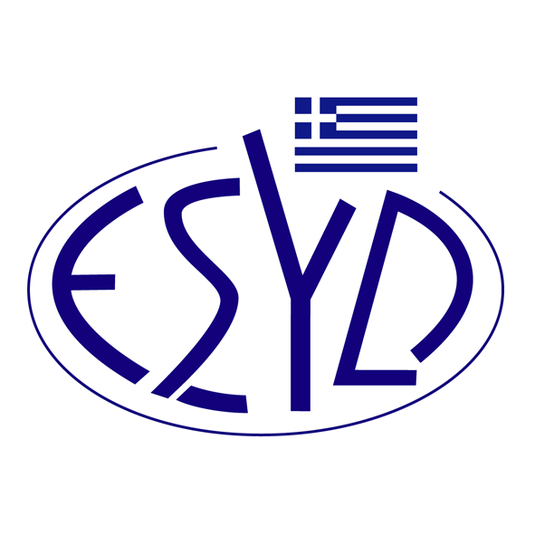

Annex A15/2 to the Certificate No. 110-10

SCOPE OF ACCREDITATION
of

QMSCERT AUDITS-INSPECTIONS-CERTIFICATIONS SA
(Q-CERT SA)

as a Certification Body of Information Technology Service Management Systems
in accordance with ISO/IEC 20000-1:2018

Activity | Standard
Certification of Information Technology Service Management Systems | ISO/IEC 20000-1:2018

Address of the Body : 28, Vlasiou Gavrielidi street, 546 55 Thessaloniki, Greece
Approved Signatory : L. Karanikas, E. Bakirtzi

This Annex is granted according to ISO/IEC 20000-6:2017.

This Scope of Accreditation replaces the previous one dated 03.04.2024.
The Accreditation Certificate Νο.110-10, according to ELOT EN ISO/IEC 17021-1:2015 is extended until 12.07.2025.

Athens, 18.12.2024

Konstantinos Kourtalis
Chairman of ESYD

