Hellenic Accreditation System

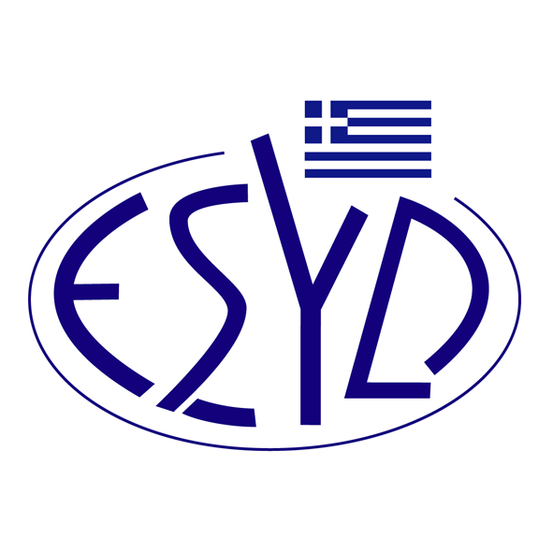

Annex A16/2 to the Certificate No. 110-10

SCOPE OF ACCREDITATION
of

QMSCERT AUDITS-INSPECTIONS-CERTIFICATIONS SA
(Q-CERT SA)

as a Certification Body of Business Continuity Management Systems
in accordance with ELOT EN ΙSΟ 22301:2019

ΕΑ/IAF  Code ⁽¹⁾ | Accredited Activity
3 | Food products, beverages and tobacco
17 | Manufacture of basic metals and fabricated metal products.
18 | Manufacture of machinery and equipment.
28 | Construction of buildings and civil engineering works.
29 | Wholesale and retail trade. Repair of motor vehicles and motorcycles. Personal and household goods.
30 | Hotels and restaurants.
31 | Transport, storage and communication.
33 | Information technology.
34 | Architectural and engineering activities. Technical consultancy. Research and development.
35 | Other services, except trade, hotels, restaurants, transport, financial intermediation, real estate, information technology, education, health and social work.
⁽¹⁾ ΕA/IAF Code according to IAF ID 1:2020.

Addresses of the Body : 28, Vlasiou Gavrielidi street, 546 55, Thessaloniki, Greece
Approved signatories : L. Karanikas, E. Bakirtzi

This Scope of Accreditation replaces the previous one dated 09.10.2024.
The Accreditation Certificate Νο.110-10, according to ELOT EN ISO/IEC 17021-1:2015 is extended until 12.07.2025.

Athens, 18.12.2024

Konstantinos Kourtalis
Chairman of ESYD

