Hellenic Accreditation System
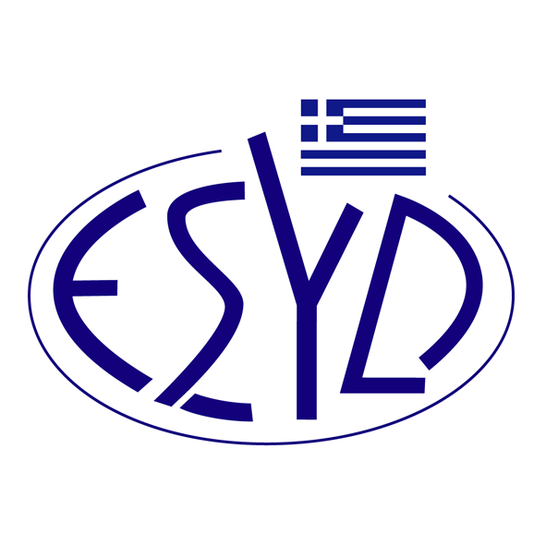

Annex Α13/9 to the Certificate No. 193-7

SCOPE of ACCREDITATION
of

EQA – HELLAS CERTIFICATION & INSPECTION BODY SOCIETE ANONYME
(EQA – HELLAS S.A.)

as an Environmental Management Systems Certification Body
in accordance with ELOT EN ISO 14001:2015

NACE Code⁽¹⁾ | Activity
18.1 | Printing and service activities related to printing.
20.3 | Manufacture of paints, varnishes and similar coatings, printing ink and mastics.
20.4 | Manufacture of soap and detergents, cleaning and polishing preparations, perfumes and toilet preparations.
22 | Manufacture of rubber and plastic products.
27.12 | Manufacture of electricity distribution and control apparatus.
28 | Manufacture of machinery and equipment n.e.c.
33.12 | Repair of machinery.
33.13 | Repair of electronic and optical equipment.
33.14 | Repair of electrical equipment.
33.2 | Installation of industrial machinery and equipment.
37 | Sewerage.
38 | Waste collection, treatment and disposal activities. Materials recovery.
41 | Construction of buildings
42 | Civil engineering.
43 | Specialised construction activities.
45 | Wholesale and retail trade and repair of motor vehicles and motorcycles.
46 | Wholesale trade, except of motor vehicles and motorcycles.
NACE Code⁽¹⁾ | Activity
47 | Retail trade, except of motor vehicles and motorcycles.
49.3 | Other passenger land transport.
49.4 | Freight transport by road and removal services.
49.5 | Transport via pipeline.
52.1 | Warehousing and storage.
52.21 | Service activities incidental to land transportation.
53 | Postal and courier activities.
55 | Accommodation.
56 | Food and beverage service activities.
58 | Publishing activities.
59.2 | Sound recording and music publishing activities.
62 | Computer programming, consultancy and related activities.
63.1 | Data processing, hosting and related activities. Web portals.
68 | Real estate activities.
69 | Legal and accounting activities.
70 | Activities of head offices; management consultancy activities.
71 | Architectural and engineering activities. Technical testing and analysis.
73 | Advertising and market research.
74 | Other professional, scientific and technical activities.
77 | Rental and leasing activities.
78 | Employment activities.
80 | Security and investigation activities.
81 | Services to buildings and landscape activities.
82 | Office administrative, office support and other business support activities.

⁽¹⁾ NACE Code (Statistical Classification of Economic Activities in the European Community) in accordance with the Regulation 1893/2006/EC of the European Parliament and of the Council.

Address of the Body: 30, Potamou Kalama str, 152 33, Chalandri, Greece
Approved signatory: Charalambos Galatsanos

This Scope of Accreditation replaces the previous one dated 10.09.2021.
The Accreditation Certificate Νο.193-7, according to ELOT EN ISO/IEC 17021-1:2015, is valid until 16.09.2024.

Athens, 10.05.2023

Christos Nestoras
CEO of ESYD

